Coastal Carolina University

Factor Analysis of Pitch Design:

Tilt, Release Height, Induced Vertical Break, & Horizontal Break

Scott Kobos Dr. T. Brian Bunton

Applied Physics Advisor

December 9th, 2019

The game of baseball has experienced an extraordinary surge in the use of technology in player development at all levels. These technologies have allowed us to identify many important factors that explain a pitcher’s ability to manipulate the movement of a pitch. For this work a factor analysis of four elements of pitch design: tilt, release height, horizontal movement, and induced vertical break, was performed to investigate which element, or combinations of elements, result in the lowest exit velocities possible, along with the physical properties that explain the behaviors of the pitch and how the ability to understand and implement the knowledge of these properties allows a pitcher to increase their likelihood of success.

With cooperation from Drew Thomas, the pitching coach for the Coastal Carolina University baseball team, access was given to the TrackMan data of the team, which installed the TrackMan unit prior to the 2017 season. The statistical computation software, R, was used to organize and filter the data, as well as performing the statistical analysis.

The Master-TrackMan data file was downloaded as a Microsoft Excel file from the national TrackMan database. The file was then imported into R and the filtering process began. Trimming the Master-TrackMan data from its original size of over 33,000 pitches first began by eliminating all non-Coastal Carolina pitchers from the data set. Following the exclusion of non-Coastal Carolina pitchers, it was necessary to exclude four submarine-style pitchers from the past three years at Coastal Carolina. This was done due to the style at which submarine pitchers throw—from either sidearm or lower than the horizontal axis of their center of mass would alter the measurements of two factors, tilt and release height, that are being analyzed. Keeping these submarine pitchers, who were all righthanded, in the dataset would interfere with the analysis of the rest of the righthanded pitchers who use a more traditional delivery and arm slot. From the new data set that included only Coastal Carolina pitchers with traditional deliveries and arm slots, the data set was further filtered to eliminate all non-fastball pitches—sliders, curveballs, and changeups. Further sorting split into four groups; lefthanded pitcher 4-seam fastballs, lefthanded pitcher 2-seam fastballs, righthanded pitcher 4-seam fastballs, and righthanded pitcher 2-seam fastballs. The factors of tilt and horizontal break required the sorting of pitchers by handedness due to the effect it has on the measurements of these factors. A problem that was encountered was that TrackMan does not separate fastballs into 2-seam and 4-seam fastballs. This distinction had to be made based on the tilt of the pitch. Lefthanded 4-seam fastballs are thrown in a range of tilts from 11:00 to 12:00, 2-seams from 9:45-10:15. Righthanded 4-seam fastballs are thrown from 1:00 to 12:00 with their 2-seams ranging from 1:45 to 2:30. The ranges of tilts to differentiate between 4-seam and 2-seam fastballs were made by Coastal Carolina pitching coach Drew Thomas. It was also necessary to convert the tilt values from the clock-like axis into radians in order for R to properly plot the factor. This was done using the hms2rad() function from the astroFns package created by Andrew Harris, professor and chair of astronomy at the University of Maryland. After the filtering process, graphs of factor vs. exit velocity were made, the first step of analysis of our data.

Four graphs per group were constructed in R; exit velocity vs. tilt, exit velocity vs release height, exit velocity vs. horizontal break, exit velocity vs. induced vertical break. Linear regression was run on these graphs and none showed any statistical significance between the factor and exit velocity. The next step used correlation matrices and multi-factor linear regression to perform the multi-factor analysis.

Prior to understanding further analysis, it is imperative to understand the significance of the factors and their influence on the trajectory of a pitch.

The first factor, tilt, also known as spin axis, as defined by TrackMan Baseball, is measured on a clock-like axis and measures the spin direction of a pitch. The graphic below shows an example of how the axis of tilt for a lefthanded pitcher can be visualized from the pitchers’ point of view:

Figure [1]

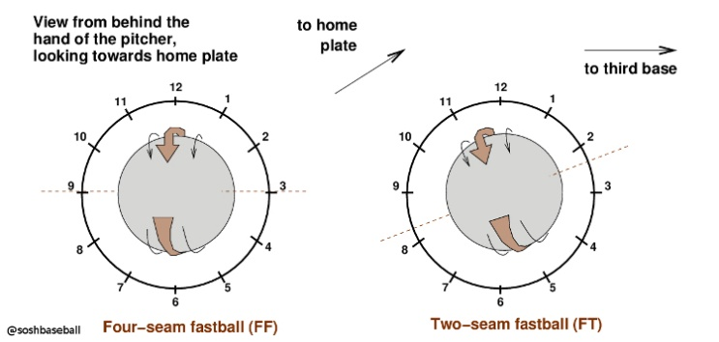

Tilt is dependent on the handedness of the pitcher in most pitch cases, except a perfectly back-spun 4-seam fastball and a perfectly top-spun curveball that are thrown with a 12:00 backspin and 6:00 topspin, respectively. These pitches are usually thrown within a certain range of tilts that are largely dependent on the hand and finger position before and immediately after the pitch is thrown. As mentioned in the description filtering process, 4-seam tilts range from 11:00 to 12:00 for lefthanded pitchers and 12:00-1:00 for righthanded pitchers, while the 2-seam tilts range from 9:45 to 10:15 for lefthanded pitchers and 1:45 to 2:30 for righthanded pitchers. While tilt itself may not directly influence exit velocity, it does affect other characteristics of a pitch such as spin efficiency. While spin efficiency is outside the scope of this work, we know higher spin efficiency is more desirable than lower spin efficiency, so optimizing tilt optimizes results.

The horizontal break is defined by TrackMan Baseball as the distance between where the pitch crosses the front of home plate versus where the pitch would have crossed home plate if it had traveled in a perfectly straight line from release, measured in inches. In baseball vernacular when discussing pitch characteristics, the break is defined as any movement that deviates from the path of a ball thrown perfectly straight. The sign of the value of horizontal break is dependent on the handedness of the pitcher. For left-handed pitchers, the horizontal break will be negative and for righthanded pitchers horizontal break is positive. This distinction is based solely on TrackMans’ choosing to measure the value without adjusting for the handedness of the pitcher, anything moving to the right is moving in the positive direction and moving to the left is in the negative direction. For the Coastal Carolina pitching staff, an approximate range of horizontal break for 4-seam fastballs are from -2 to 13 inches for righthanded pitchers. For lefthanded 4-seam fastballs, the range is from 1 to -13 inches. For 4-seam fastballs, a 0 value indicates no horizontal movement, an ideal horizontal movement for lefthanded pitchers is a negative value and an ideal horizontal movement for righthanded pitchers is a positive value. However, both ranges of horizontal movements offer non-ideal horizontal movement values—positive for lefthanded pitchers and negative for righthanded pitchers. This non-ideal horizontal movement is defined as “cut.” This cutting action is a horizontal break on a pitch towards the glove side of the pitcher; to the right for lefthanded pitchers and to the left for right-handed pitchers. For 2-seam fastballs, the range is 7 to 20 inches for righthanded pitchers and the same for lefthanded pitchers, but negative. Horizontal break is important because conventional thinking tells us that more movement a pitch has, the harder it is to hit.

Induced vertical break, defined by TrackMan baseball is the distance between where the pitch crosses the plate and where it would have crossed the plate if it would have traveled in a perfectly straight line from release, unaffected by gravity, measured in inches. Unlike tilt and horizontal break, the induced vertical break is not affected by the handedness of the pitcher. For the Coastal Carolina pitching staff, ranges of induced vertical break are from 9 to 25 inches for 4-seam fastballs and 5 to 20 inches for 2-seam fastballs. Until the flourish of the use of technology in baseball, induced vertical break was merely a quality of a pitch that can only be qualified by the “eye-test” as a pitch having “life” or being “electric.” This quality made the pitch more difficult to catch up to and more difficult to hit well.

The final factor, release height, TrackMan has defined as the height above home plate at which the pitcher releases the ball, measured in feet. Like induced vertical break, release height does not depend on the handedness of the pitcher. For the Coastal Carolina pitching staff, the range of release heights has been from 5 to 6.5 feet above the ground. Release height has no clear impact on exit velocity and is a product of a pitcher’s mechanics and movement quality.

Now that we understand the significance behind our factors, we can explore the physics behind pitch design and learn what makes a pitch behave the way that it does. From the four factors, release height does not necessarily affect pitch movement, but tilt greatly influences both horizontal and induced vertical break, that will be explained further on.

The most commonly known influence of pitch movement is the Magnus force/effect. The Magnus force is the force exerted on a rapidly spinning cylinder or sphere moving through air or another fluid in a direction perpendicular to the axis of spin, that increases with both speed and revolutions per minute (rpm). From this force, we can see the Magnus effect which, within the pitch design perspective, can be seen best in the “rise” of a 4-seam fastball, or the sharp downward break of a curveball. For Magnus force, tilt (paired with spin rate) is the most important thing. A pitch with lower tilt will essentially waste the Magnus force, because it will be directed diagonally instead of straight up, taking less advantage of the Magnus effect. While this effect is the primary explanation of pitch behavior after release for a 4-seam fastball, it is not the sole explanation for the movement of a pitch. For more technical pitch aerodynamics, focus will be shifted to the 2-seam fastball.

Dr. Barton L. Smith, a professor of Mechanical and Aerospace Engineering at Utah State University has done great work exploring less obvious explanations for pitch movement. Dr. Smith has taken to using Particle Image Velocimetry to observe the interaction of the ball and the seams with the air as it travels its’ path to home plate. Particle Image Velocimetry (PIV) is an optical method of flow visualization used to obtain instantaneous velocity measurements and related properties in fluids. The fluid, in this case, air, is seeded with tracer particles—at a sufficiently small size that is assumed to follow the flow dynamics or the fluid. The motion of these particles is used to calculate the speed and direction (velocity field) of the flow [2]. The following picture is of a ball, mid-flight, photographed from above from the PIV performed by Dr. Smith, colored to indicate air velocity; red being a large velocity to the left and blue being zero velocity.

Figure [2]

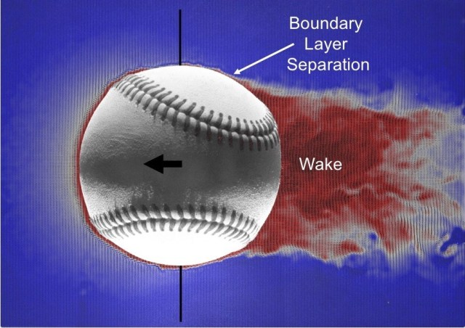

From this image, we can see that there is a red region around the front of that ball that wraps around the greater part of the circumference of the ball until it reaches the point labeled Boundary Layer Separation in the image. The boundary layer on a spherical object, the ball, is where the fluid, air, and the surface of the ball meet. The boundary layer will remain on the surface of the ball when the flow is stable (front of the ball) and will detach when the flow is unstable (back of the ball); the difference in pressure is drag [2]. Where the boundary layer separates is key for the movement of a pitch because at that point is where the wake begins to form. In aerodynamics, a wake is defined as the region of a decelerated fluid that arises behind the body around which the fluid flows. The wake is significant because the size, location, and angle of the wake is a determining factor in the movement of a pitch. If the boundary layer separates further back on the ball, pushing the wake back, a sideways pressure force forms that can cause movement [3].

Another way to visualize boundary layer separation and the wake is through vorticity. Vorticity is how much the air is spinning around the ball. The mathematical representation of vorticity is as follows:

The vorticity is the curl of the velocity vector around the ball, with representing the vorticity vector and v representing the velocity vector[4]. In the image below, you can see the Boundary Layer Separation and Wake formation; the colors are insignificant.

Figure [2]

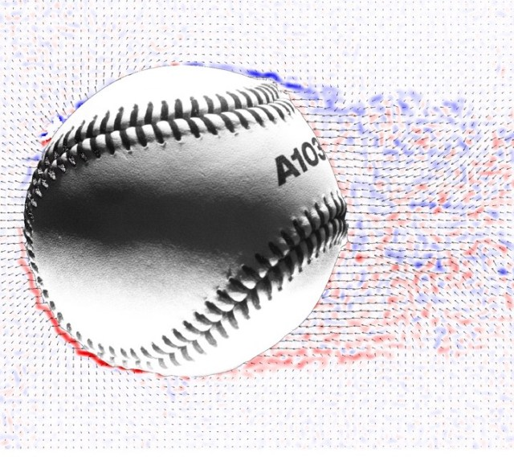

The above image shows how the ball and air interact with each other as it spins but is only part of the explanation as to why a pitch can move the way that it does. To continue to explore the physical influences on pitch-behavior, we will focus a particular 2-seam fastball dubbed, the “Laminar Express.”

The pitch, fathered by current Cincinnati Reds pitcher Trevor Bauer, is a 2-seam fastball that has significantly more horizontal break than the standard 2-seam fastball. At the time, it was just speculation that it was due to the laminar/turbulent effect on a baseball, hence the name Laminar Express [5]. Dr. Smith has since proved their theory. To begin to understand this pitch, it is imperative to understand the difference between laminar and turbulent flow, the influence of pressure on ball flight, and how the construction of a baseball influences both. Laminar flow is smooth and orderly and has a constant velocity at any point in the fluid while turbulent flow is rough and chaotic.

A huge factor in the relationship between laminar and turbulent flow in pitch design is pressure. Just as the Magnus force follows the path of the transition from high to low pressure, this also influences the formation of the boundary layer separation and wake. The following graphic shows a baseball traveling from right to left through air and graphs of velocity and pressure along the horizontal axis of the ball.

Figure [6]

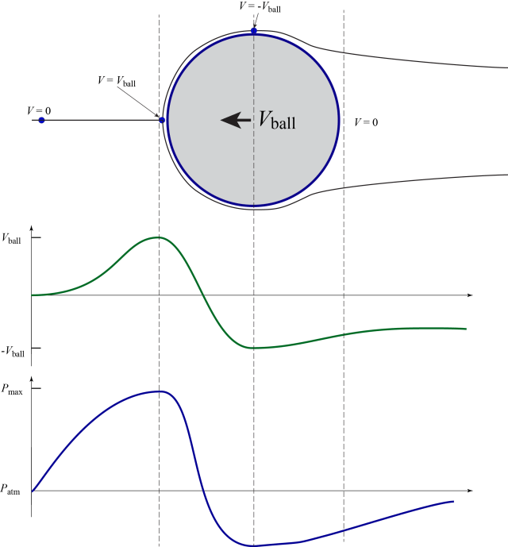

The magnitude of the pressure is not important, it is extremely important whether or not the pressure is uphill or downhill. Uphill pressure is “forgiving” and travels from low to high pressure. Downhill pressure is “unforgiving” and travels from high to low pressure. If you disturb the flow while the pressure hill is forgiving, it will return to its’ original condition. The more forgiving the pressure gradient is, the more likely the flow forgets about the seams, but as soon as the flow becomes unforgiving, the boundary layer separates and the wake is formed. The importance of pressure in the relationship between turbulent and laminar flow is that a turbulent boundary is more able to maintain its’ attachment in an unforgiving area than a laminar boundary layer, which can be seen by the following graphic[6].

Figure [6]

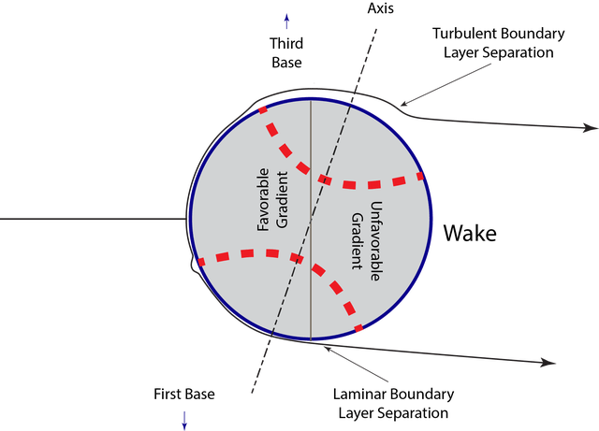

As mentioned earlier in the paper, the location of the formation of the wake is extremely important because the further back the wake forms, the more likely a force induces horizontal movement on the ball. Since a turbulent boundary separates further behind the ball than the laminar layer, it shifts the angle of the wake in the direction of the turbulent boundary layer, producing the force on the ball necessary to create horizontal movement in the direction of the side of the turbulent flow. This can be shown by the acceleration of Steven Strasburg’s—a right-handed pitcher for the Washington Nationals—changeup. While it doesn’t occur every single time that he throws the pitch, about 10% of his changeups accelerate downward with more than the force of gravity. This occurs from the seams of the ball shifting the wake into a position to create that force.

Figure [3]

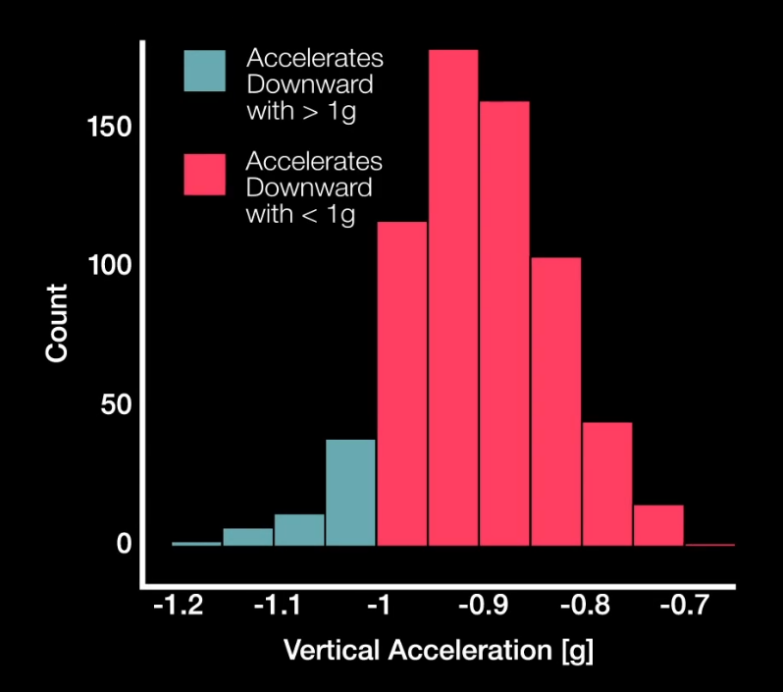

The final aspect of the Laminar Express, or any fastball, is tilt. This is without a doubt the most influential factor when it comes to producing the trajectory of a pitch. This next image, taken from the side, shows the vorticity of two baseballs in flight, with the wake marked.

Figure [7]

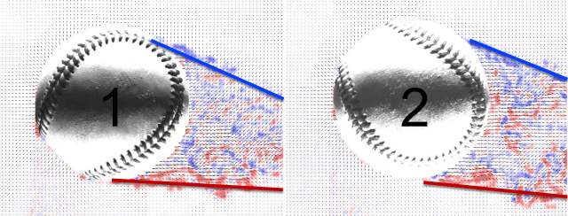

You can see two very different wakes from this image. The ball on the left has a longer Wake than that of the ball on the right, meaning that Ball 1 has lower drag than Ball 2. Yet, these are the same ball at different points of rotation. What this shows us is that the wake shifts due to seam orientation during flight[7]. While a shift in wake would result in the production of movement, this shift happens so many times throughout the flight of the ball—MLB average fastball spin rate is 2300 rpm—that these shifts average out to nothing. This applies to both 2-seam and 4-seam fastballs. So why is tilt important? We can begin to explore the difference between the guidelines set by the filtering process or our data. 4-seam tilts are much closer to 12:00, or true backspin, than 2-seam fastballs that, for lefthanded pitchers, can range from 9:45 to 10:15 and 1:45 to 2:30 for righthanded pitchers. This lower spin axis results in the production of a greater horizontal break in 2-seam fastballs vs. 4-seam fastballs. Along with this difference in tilt, which is produced by the difference in the grip of the pitches, the seam orientation, affected by tilt, plays a large factor. Without seams, the boundary layer will separate evenly, producing a uniform wake—having no angle—and creating no additional movement outside the effects of gravity and the Magnus force. Seams shift the wake by creating uneven boundary layer separations that promote additional movement to a pitch beside the expected effects of Magnus force and gravity[7].

After plotting each factor individually against exit velocity provided nothing of any statistical significance, models for every combination of factors against exit velocity were made. There were four combinations of three of the factors, six combinations of two of the factors, and one combination of all four factors. Before analyzing the results of these models, it is imperative to check the assumptions for the model to determine its appropriateness. All plots and model summaries can be found in the appendices A-D: lefthanded pitcher 4-seam fastballs, lefthanded pitcher 2-seam fastballs, righthanded pitcher 4-seam fastballs, righthanded pitcher 2-seam fastballs

The first step in checking the assumptions of the models was to create Added-Variable plots in R and observe the slopes of the lines within. For these plots, four graphs were made, one for each factor in the study. The added-variable plots test whether each variable adds new information to the model that does not come from a previously used factor. If the slope of the line is 0, it means that there is no additional information being contributed by that factor. The larger the slope the more information that a variable is adding to the model. Following the Added-Variable Plots, the plot(model) function is used to create four more graphs:

To pass, these plot tests of these four graphs, they must meet the conditions of each graph. For the Residual vs. Fitted values Plot, the data must appear random, the key is to not observe a funnel shape or any discernible pattern. This checks for constant variance, as non-constant variance implies a lack of fit. The Normal Probability Plot will produce a straight line if all error is distributed normally; however, with a large enough sample size, the line may deviate from linear and still be accepted. The Scale-Location plot shows if the residuals are spread equally on the range of predictors and like the normal probability plot, should appear random, with no discernible pattern. This checks for equal variance, or homoscedasticity. Cook’s Distance Plot identifies leverage points within the data. A general rule in interpreting Cook’s distance is that any value with a distance greater than 1 is influential and should be investigated. The final assumption to check is the variance inflation factor (vif). The variance inflation factor shows whether or not some variables can be written as linear combinations of the other variables being tested. Any vif under 15 for a variable is considered acceptable.

The summary of all 4 of our models—LHP2S, LHP4S, RHP2S, RHP4S—there is no statistically significant evidence that any of our four factors influence exit velocity. Although the desire to find a relationship between our factors and exit velocity was not filled, we did confirm the inverse relationship (negative correlation) between tilt and horizontal break and a direct relationship (positive correlation) between tilt and induced vertical break. For all models, as tilt increased, horizontal break decreased. While the models for LHP2S and RHP2S showed a positive correlation between tilt and induced vertical break. These relationships fit perfectly into our physical explanations of pitch behavior. For the tilt and horizontal break’s negative correlation, the physics tells us that a 2-seam and 4-seam with the same tilt will produce the same trajectory of the pitch[7]. The difference between the pitches is the tilt produced by hand position that allows the seam to shift the wake, producing the force that creates horizontal movement. The relationship between tilt and induced vertical break for 2-seam fastballs is slightly less intuitive. Another name for a 2-seam is “sinker” because of the tendency of the pitch to “sink” down in the zone. This is still caused by the seams shifting the wake of the pitch, but rarely (essentially never) is the force produced only in a horizontal direction. There is always some vertical component to this force and when it is greater than the horizontal component of the force, we identify the pitch as a sinker rather than a 2-seam. This is very similar to the movement produced by Steven Strasburg in his changeup. The changeup has a much lower tilt than a 2-seam fastball which is why we see it accelerate downwards more than horizontally. So, when a 2-seam fastball is thrown with a greater higher, the entire additional force is decreased, allowing the ball to hold its’ height more than it would have with a lower tilt; higher tilt leads to a smaller force, leading to less drop from the force and greater induced vertical break.

To continue to progress this work further, there are a few avenues of exploration that can be taken. First, our analysis could include all factors measured by the TrackMan system, a total of 36 additional factors. During this analysis, only batted balls that were put into play (hit fair) were considered. A good idea would be to include swing and misses into the scope of the data, as that is the most ideal outcome, a pitch that is so good that it isn’t touched by the batter. With that comes the added variables such as pitch location and “chases,” where a batter swings at a ball outside the strike zone, but TrackMan collects data on that as well so chases could be excluded from the set. A final way to progress this work would be to include non-fastball pitches—changeups, sliders, curveballs, splitters, etc. This would be valuable information because not only do some pitchers throw their off-speed (non-fastball) pitches more often than their fastball(s), but it could also potentially tell us if a pitcher SHOULD throw their off-speed pitches more often than they do, if this analysis was to be performed on a case-by-case basis for each pitcher with a sufficient sample of data.

In conclusion, while the statistical analysis did not provide any useful insight into the relationship between any of the four factors of tilt, release height, induced vertical break, and horizontal break, it did confirm the physical relationship between tilt and horizontal break, while also showing relationships between tilt and induced vertical break, induced vertical break and horizontal break, and release height and induced vertical break in some cases. Continuing this work with more factors or including swing and miss into the analysis may provide a better look into the relationship between factors and exit velocity and could be applied to a case-by-case basis if desired.

Works Cited

[1] Aucoin, Dan. “Mastering The Axis of Rotation: A Thorough Review of Spin Axis in Three Dimensions.” *Driveline Baseball*, Driveline Baseball, 6 Sept. 2019, www.drivelinebaseball.com/2019/09/mastering-the-axis-of-rotation-a-thorough-review-of-spin-axis-in-three-dimensions/.

[2] Smith, Barton L. “Primer on Understanding Our Results: Post 28.” *Baseball Aerodynamics*, 17 Aug. 2019, www.baseballaero.com/2019/08/17/primer-on-understanding-our-results-post-28/.

[3] Smith, Barton L. “The Seam Shifted Wake: Post 34.” *Baseball Aerodynamics*, 7 Oct. 2019, www.baseballaero.com/2019/10/07/the-seam-shifted-wake-post-34/.

[4] Swift, James H. “Vorticity.” *Descriptive Physical Oceanography*, by Lynne D. Talley, 6th ed., Academic Press, 2011, pp. 187–221.

[5] Boddy, Kyle. “Laminar Express: Using Baseball Science to Enhance Two-Seam Fastballs.” *Driveline Baseball*, Driveline Baseball, 20 Jan. 2019, www.drivelinebaseball.com/2019/01/laminar-express-baseball-science-behind-the-two-seam-fastball/.

[6] Smith, Barton L. “A Complete Description of the Laminar Express Post #15.” *Baseball Aerodynamics*, 21 June 2019, www.baseballaero.com/2019/01/27/complete-description-of-the-laminar-express/.

[7] Smith, Barton L. “Do Seams Affect Trajectory? Post #4.” *Baseball Aerodynamics*, 21 June 2019, www.baseballaero.com/2018/11/25/do-seams-affect-trajectory/.

Appendices

**Appendix A**

**Left-Handed 4-Seam Fastball Plots, & Model Summary**

Figure -LHP4S Added Variable Plots

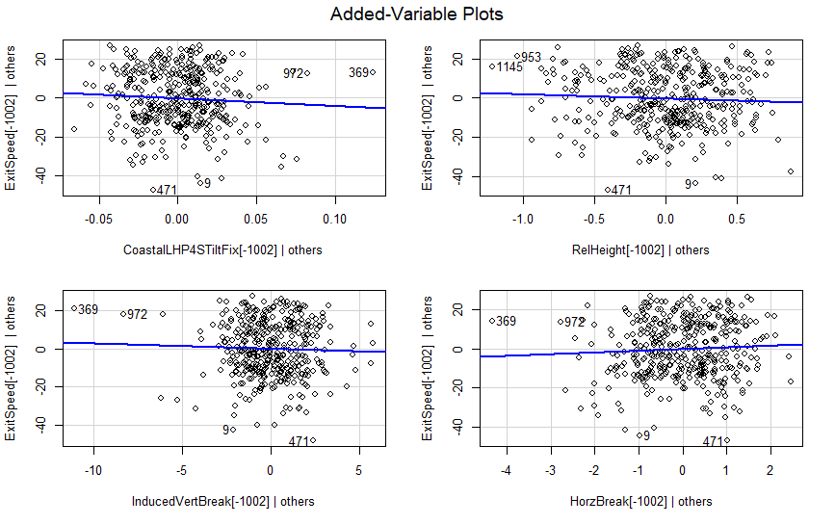

Each of these graphs have a slope that is non-zero; each additional factor adds information to the model.

Figure - LHP4S Residual vs. Fitted Plot

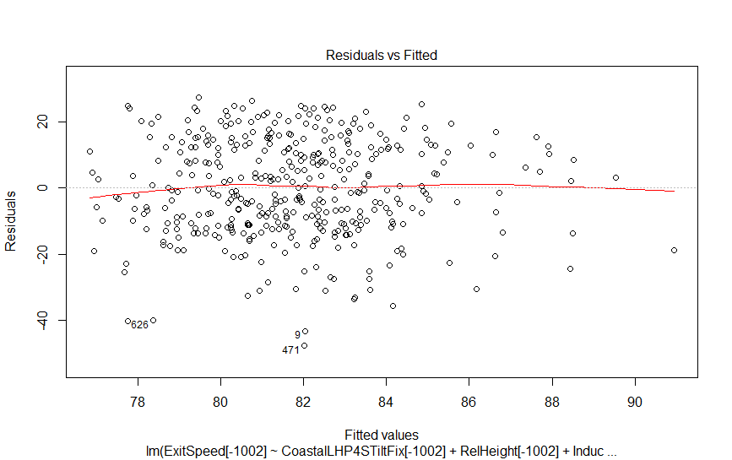

The Residuals vs Fitted Plot shows no funneling or discernable pattern, constant variance is shown.

Figure -LHP4S Normal Probability Plot

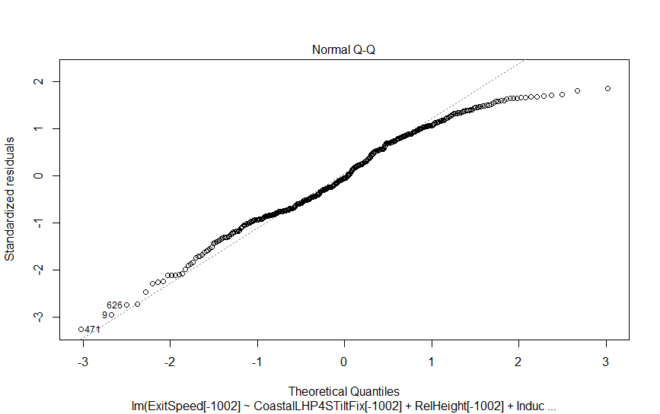

The Normal Probability Plot deviates from linear, but the sample size is sufficiently large to accept this deviation.

Figure - LHP4S Scale-Location Plot

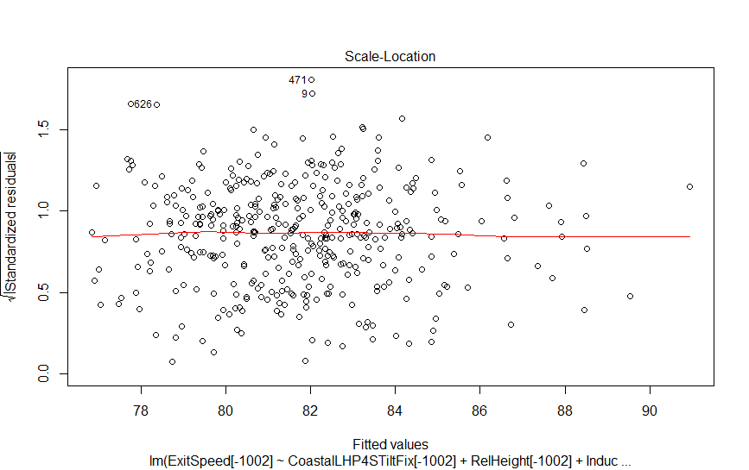

The Scale-Location Plot appears random, meeting the criteria for passing the assumption of equal variance.

Figure - LHP4S Cooke's Distance Plot

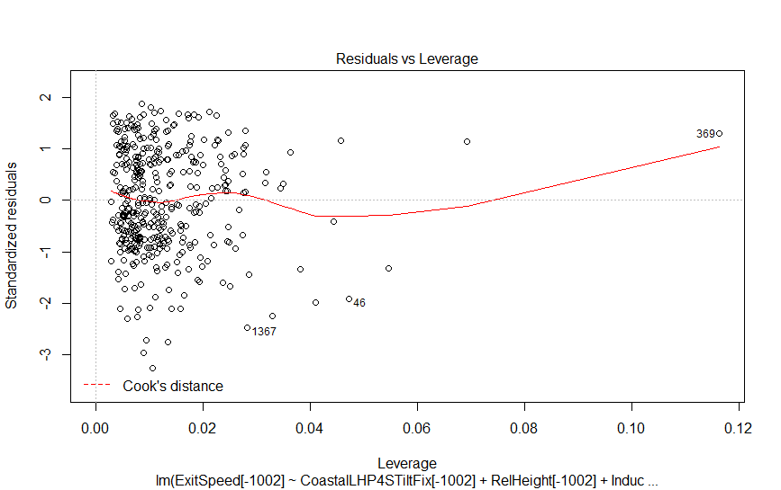

The Cook’s Distance Plot shows no influential cases within the data set. The final test for the model is the variance inflation factor, which the model passes.

The model also passes vif testing:

> vif(LHP4STIHR.mod)

CoastalLHP4STiltFix[-1002] RelHeight[-1002] InducedVertBreak[-1002] HorzBreak[-1002]

9.448746 1.157054 2.106317 10.254556

Call:

lm(formula = ExitSpeed[-1002] ~ CoastalLHP4STiltFix[-1002] +

RelHeight[-1002] + InducedVertBreak[-1002] + HorzBreak[-1002])

Residuals:

Min 1Q Median 3Q Max

-47.756 -10.746 -0.712 12.331 27.299

Coefficients:

Estimate Std. Error t value Pr(>|t|)

(Intercept) 222.6222 89.5427 2.486 0.0133 *

CoastalLHP4STiltFix[-1002] -39.6368 30.3245 -1.307 0.1919

RelHeight[-1002] -2.1791 2.0209 -1.078 0.2816

InducedVertBreak[-1002] -0.2771 0.3957 -0.700 0.4841

HorzBreak[-1002] 0.8386 0.7557 1.110 0.2678

---

Signif. codes: 0 ‘***’ 0.001 ‘**’ 0.01 ‘*’ 0.05 ‘.’ 0.1 ‘ ’ 1

Residual standard error: 14.72 on 394 degrees of freedom

(1088 observations deleted due to missingness)

Multiple R-squared: 0.02444, Adjusted R-squared: 0.01453

-statistic: 2.467 on 4 and 394 DF, p-value: 0.04443

**LHP4S- 1488 observations**

> cor(cbind(CoastalLHP4STiltFix[-1002],RelHeight[-1002],InducedVertBreak[-1002],HorzBreak[-1002]), use="complete.obs")

Tilt RH IDVB HB

Tilt 1.0000000 0.16234788 0.1356247 -0.63892628

RH 0.1623479 1.00000000 -0.2279446 0.07092843

IDVB 0.1356247 -0.22794459 1.0000000 0.31965229

HB -0.6389263 0.07092843 0.3196523 1.00000000

Figure - LHP4S Tilt vs. HorzBreak Plot

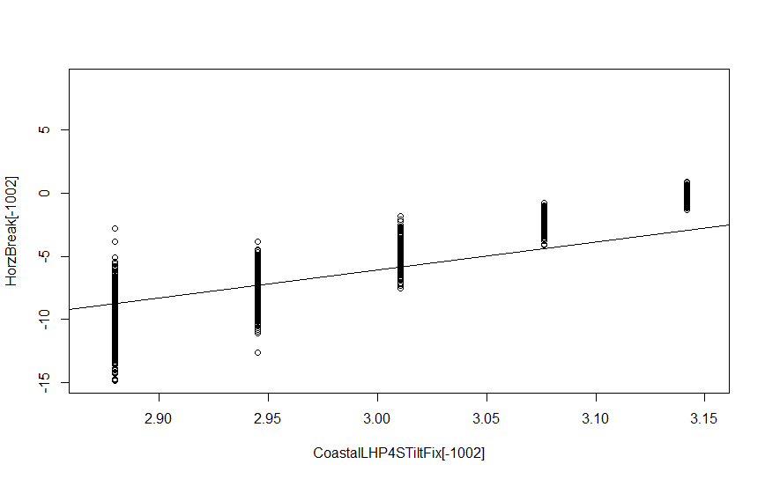

**Appendix B**

**Left-Handed 2-Seam Fastball Plots, & Model Summary**

Figure - LHP2S Added Variable Plots

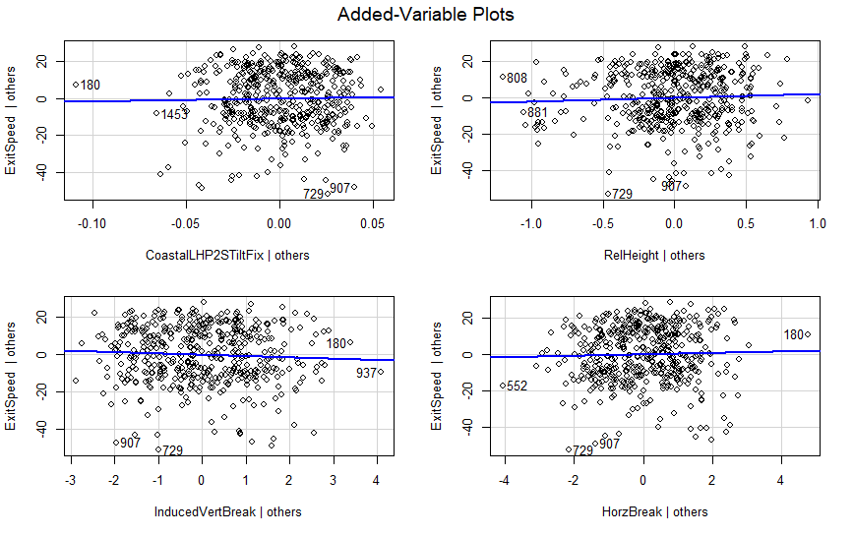

Added-Variable Plots are all non-zero.

Figure - LHP2S Residuals vs. Fitted Plot

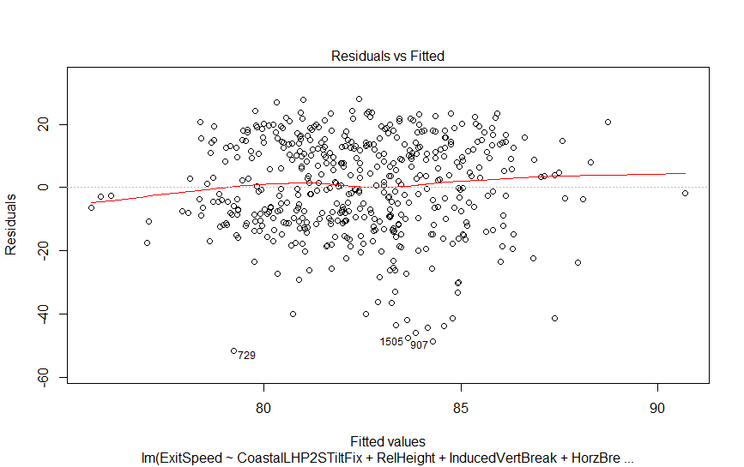

The Residuals vs. Fitted Plot is randomly scattered.

Figure - LHP2S Normal Probability Plot

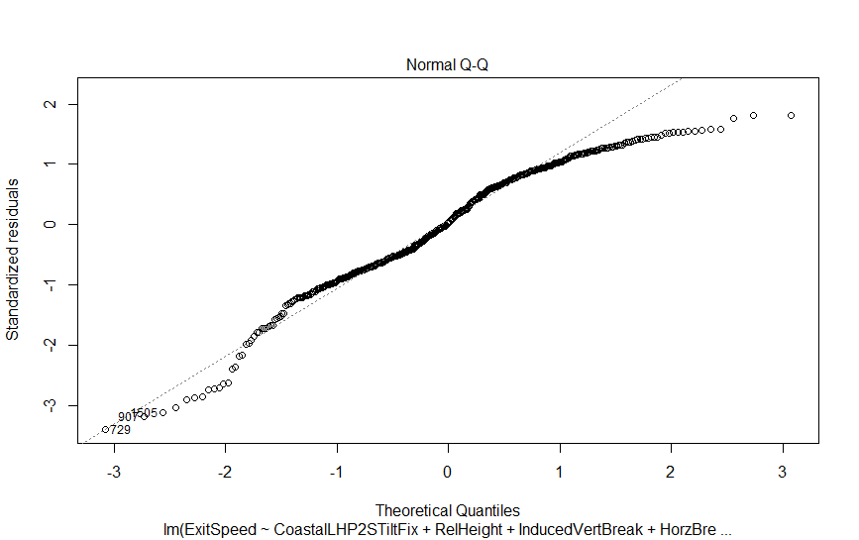

The Normal Probability Plot once again deviates from linearity but has a large enough sample size to accept.

Figure - LHP2S Scale Location Plot

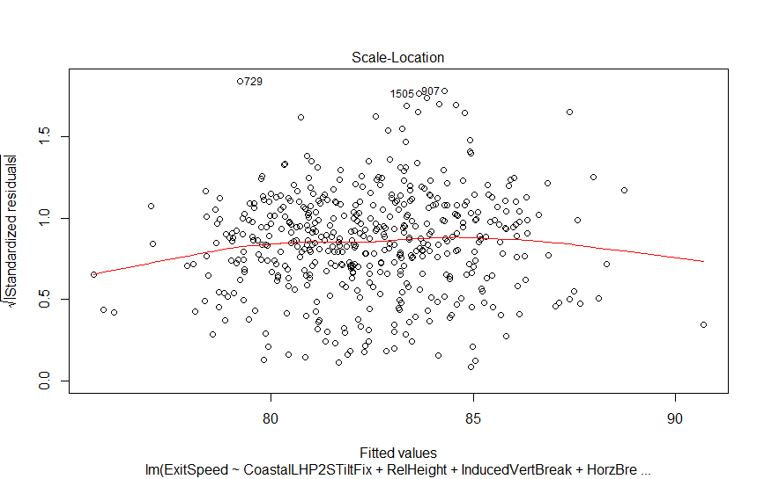

The Scale-Location Plot also appears random, meeting the criteria for passing the assumption of equal variance.

Figure - LHP2S Cooke's Distance Plot

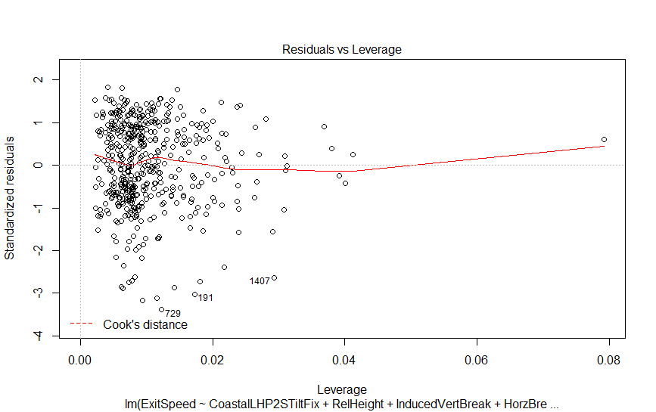

The Cook’s Distance Plot shows no influential cases within the data set.

The model also passes the variance inflation factor testing:

> vif(LHP2STIHR.mod)

CoastalLHP2STiltFix RelHeight InducedVertBreak HorzBreak

7.013423 1.253225 6.478380 4.352209

Call:

lm(formula = ExitSpeed ~ CoastalLHP2STiltFix + RelHeight + InducedVertBreak +

HorzBreak)

Residuals:

Min 1Q Median 3Q Max

-51.823 -10.538 0.517 12.705 27.906

Coefficients:

Estimate Std. Error t value Pr(>|t|)

(Intercept) 47.9390 83.6639 0.573 0.567

CoastalLHP2STiltFix 13.8801 30.8077 0.451 0.653

RelHeight 2.1101 2.0548 1.027 0.305

InducedVertBreak -0.7237 0.5775 -1.253 0.211

HorzBreak 0.3947 0.5850 0.675 0.500

Residual standard error: 15.39 on 474 degrees of freedom

(1172 observations deleted due to missingness)

Multiple R-squared: 0.0216, Adjusted R-squared: 0.01334

F-statistic: 2.616 on 4 and 474 DF, p-value: 0.03461

**LHP2S- 1651 observations**

> cor(cbind(CoastalLHP2STiltFix,RelHeight,InducedVertBreak,HorzBreak), use="complete.obs")

Tilt RH IDVB HB

Tilt 1.0000000 0.1592002 0.5923583 -0.2309413

RH 0.1592002 1.0000000 -0.3816687 -0.2432283

IDVB 0.5923583 -0.3816687 1.0000000 0.3185459

HB -0.2309413 -0.2432283 0.3185459 1.0000000

Figure - LHP2S Tilt vs. HorzBreak

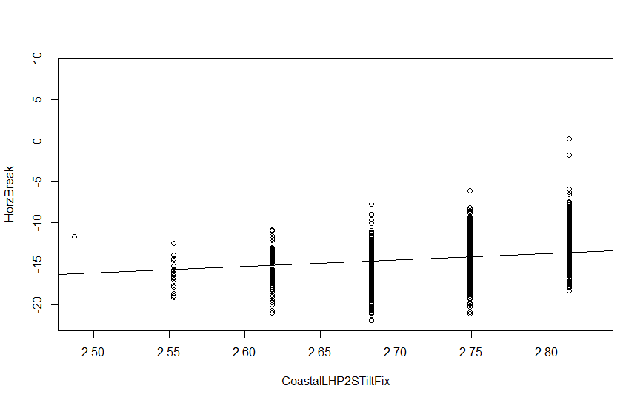

**Appendix C**

**Right-Handed 4-Seam Fastball Plots, & Model Summary**

Figure - RHP4S Added Variable Plots

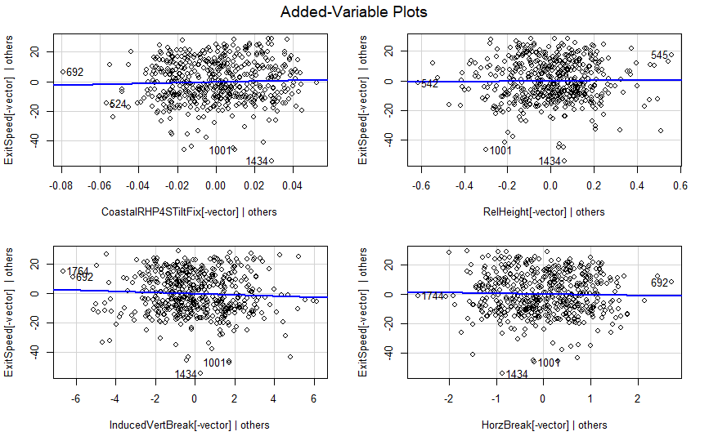

Added-Variable Plots have nonzero slope.

Figure - RHP4S Residuals vs. Fitted Plot

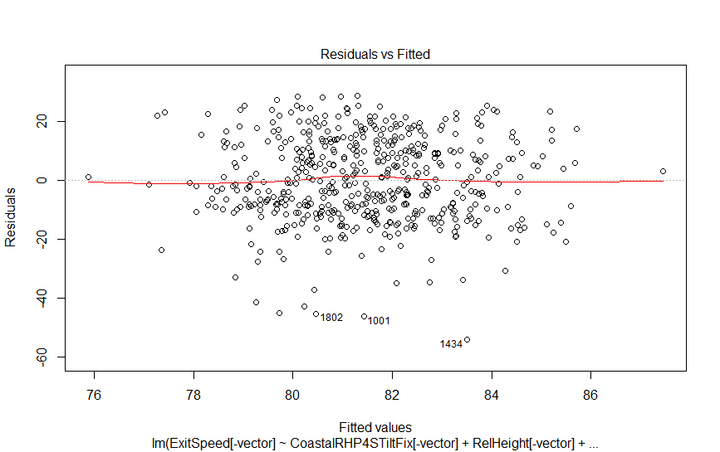

Residual vs Fitted Plot shows random scattering.

Figure - RHP4S Normal Probability Plot

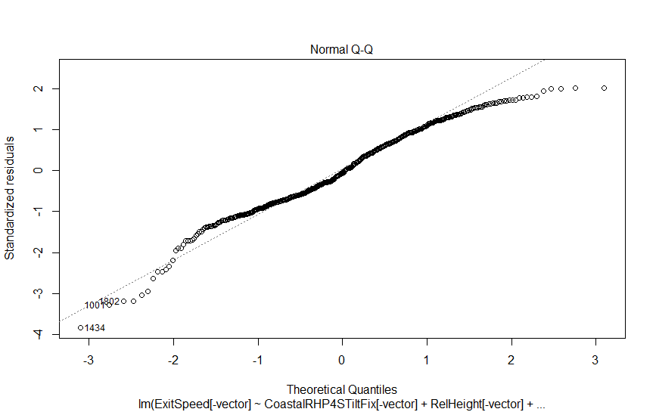

The Normal Probability Plot deviates from linearity, but with a large enough sample size to accept.

Figure - RHP4S Scale Location Plot

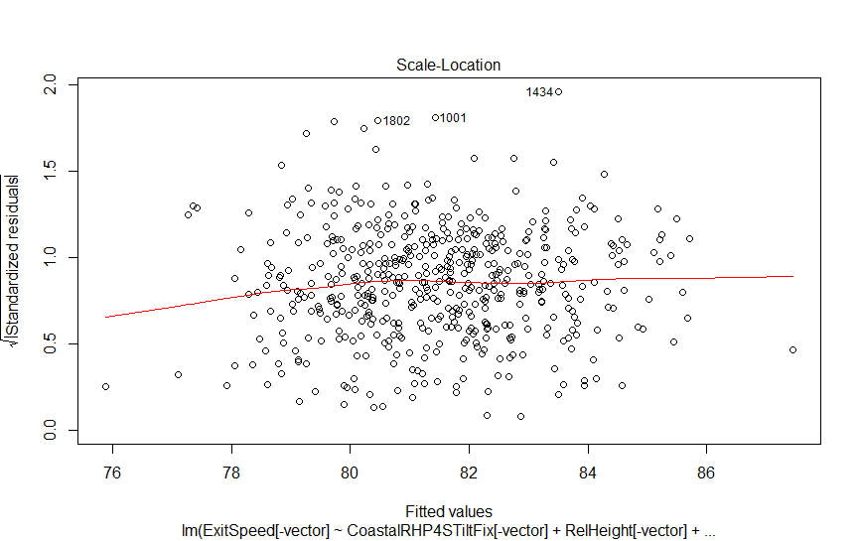

The Scale-Location Plot shows random scattering.

Figure - RHP4S Cooke's Distance Plot

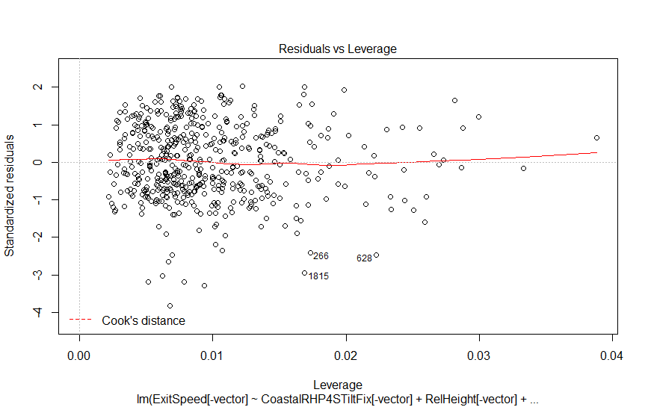

The Cook’s Distance Plot shows no influential cases in the data set.

The model also passes the variance inflation factor testing:

> vif(RHP4STIHR.mod)

CoastalRHP4STiltFix[-vector] RelHeight[-vector] InducedVertBreak[-vector] HorzBreak[-vector]

8.619620 1.465854 3.130213 11.718114

Call:

lm(formula = ExitSpeed[-vector] ~ CoastalRHP4STiltFix[-vector] +

RelHeight[-vector] + InducedVertBreak[-vector] + HorzBreak[-vector])

Residuals:

Min 1Q Median 3Q Max

-54.319 -10.079 -0.907 11.159 28.522

Coefficients:

Estimate Std. Error t value Pr(>|t|)

(Intercept) -14.3876 95.8859 -0.150 0.881

CoastalRHP4STiltFix[-vector] 29.7581 28.8008 1.033 0.302

RelHeight[-vector] 1.2139 3.6491 0.333 0.740

InducedVertBreak[-vector] -0.3850 0.3249 -1.185 0.237

HorzBreak[-vector] -0.4434 0.7462 -0.594 0.553

Residual standard error: 14.22 on 513 degrees of freedom

(1389 observations deleted due to missingness)

Multiple R-squared: 0.01421, Adjusted R-squared: 0.006528

F-statistic: 1.849 on 4 and 513 DF, p-value: 0.1181

**RHP4S- 2954 observations**

> cor(cbind(CoastalRHP4STiltFix[-vector],RelHeight[-vector],InducedVertBreak[-vector],HorzBreak[-vector]), use="complete.obs")

Tilt RH IDVB HB

Tilt 1.00000000 0.04310193 0.3601804 -0.7851545

RH 0.04310193 1.00000000 -0.4767546 0.2207076

IDVB 0.36018039 -0.47675456 1.0000000 0.5796939

HB -0.78515454 0.22070755 0.5796939 1.0000000

Figure - RHP4S Tilt vs. HorzBreak

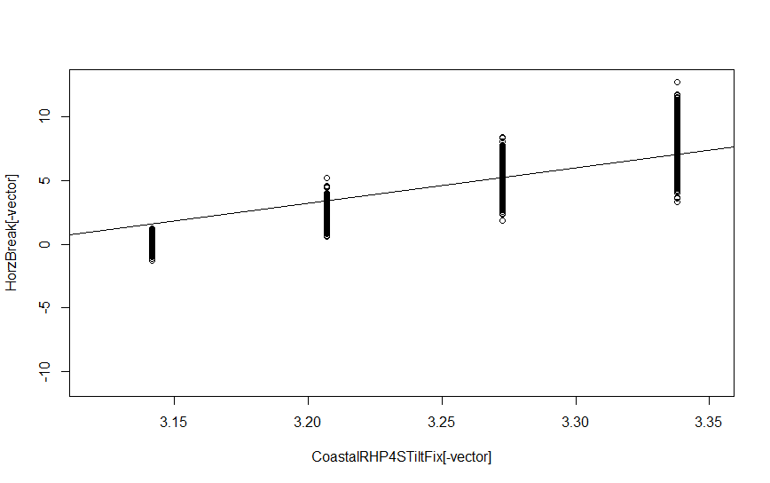

**Appendix D**

**Right-Handed 2-Seam Fastball Plots, & Model Summary**

Figure - RHP2S Added Variable Plots

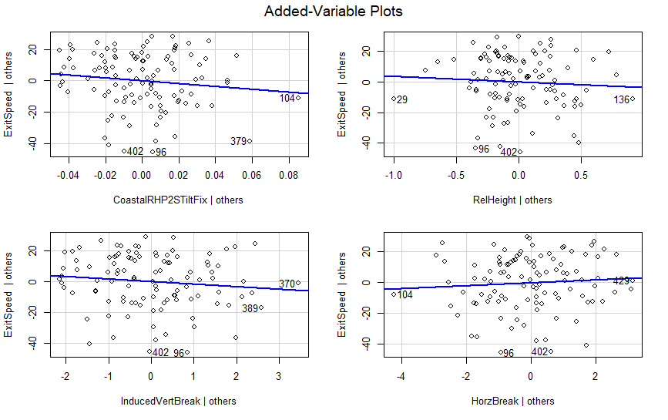

Added-Variable Plots have nonzero slope.

Figure - RHP2S Residuals vs. Fitted Plot

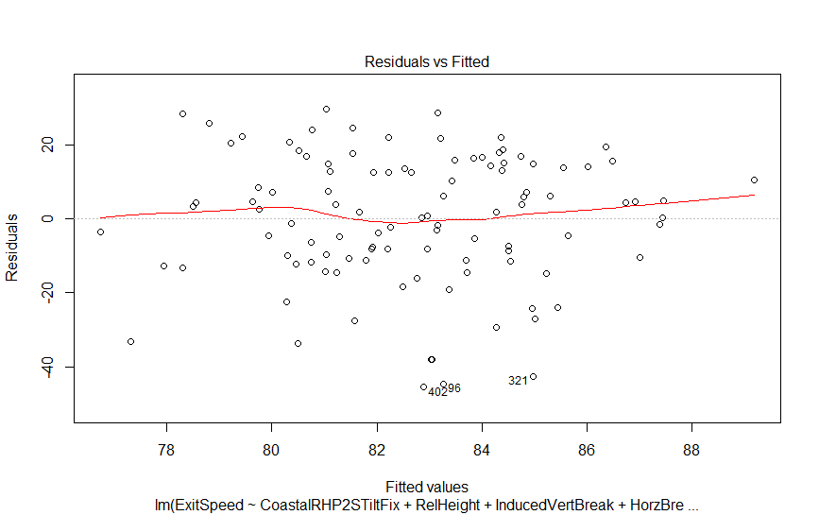

Residuals vs Fitted Plot shows random scattering.

Figure - RHP2S Normal Probability Plot

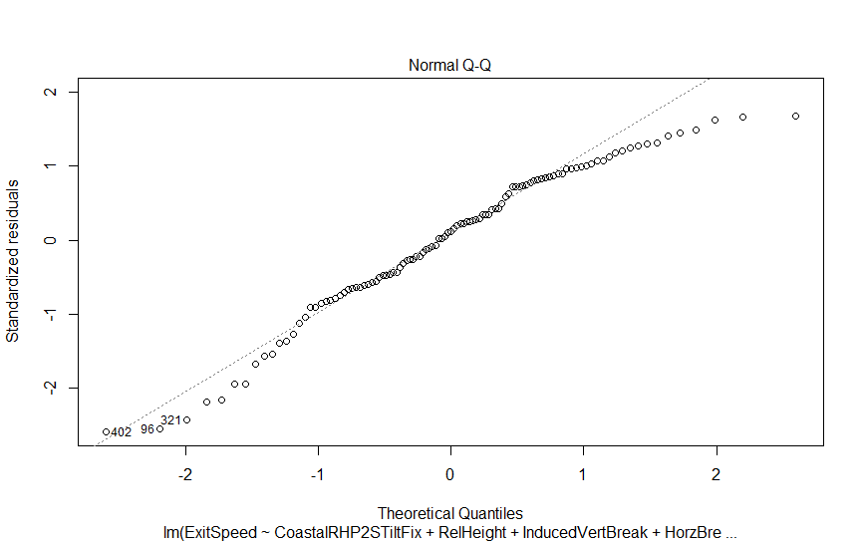

The Normal Probability Plot deviates from linearity but has a large enough sample size to accept.

Figure - RHP2S Scale Location Plot

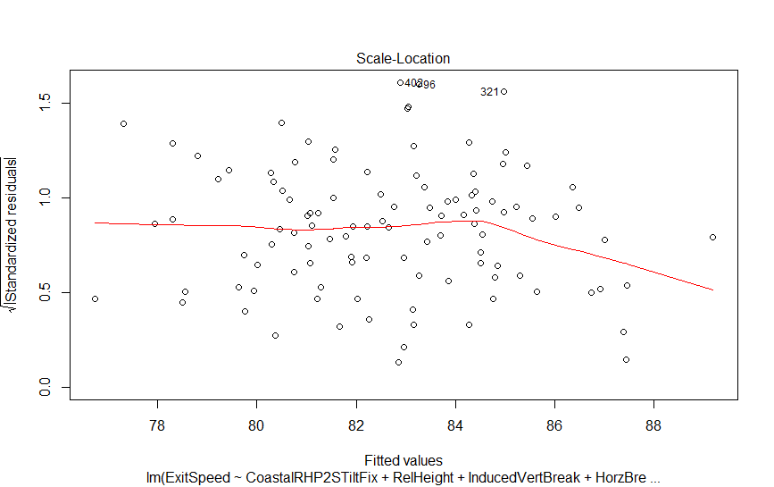

Scale-Location Plot shows random scattering.

Figure - RHP2S Cooke's Distance Plot

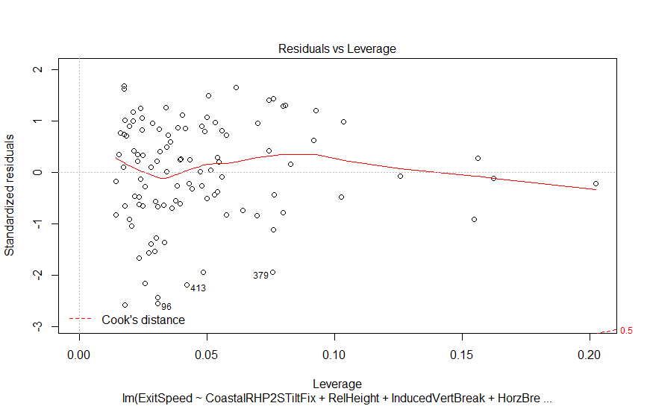

Cook’s Distance Plot shows no outlying influential observations.

The model also passed variance inflation factor testing:

> vif(RHP2STIHR.mod)

CoastalRHP2STiltFix RelHeight InducedVertBreak HorzBreak

4.116161 1.056570 5.212969 2.772403

Call:

lm(formula = ExitSpeed ~ CoastalRHP2STiltFix + RelHeight + InducedVertBreak +

HorzBreak)

Residuals:

Min 1Q Median 3Q Max

-45.59 -10.99 1.92 14.25 29.61

Coefficients:

Estimate Std. Error t value Pr(>|t|)

(Intercept) 149.9357 48.8126 3.072 0.00273 **

CoastalRHP2STiltFix -88.3532 71.9625 -1.228 0.22236

RelHeight -3.5328 5.5115 -0.641 0.52297

InducedVertBreak -1.6436 1.4485 -1.135 0.25919

HorzBreak 0.9826 1.2118 0.811 0.41930

---

Signif. codes: 0 ‘***’ 0.001 ‘**’ 0.01 ‘*’ 0.05 ‘.’ 0.1 ‘ ’ 1

Residual standard error: 17.79 on 102 degrees of freedom

(356 observations deleted due to missingness)

Multiple R-squared: 0.01956, Adjusted R-squared: -0.01889

F-statistic: 0.5087 on 4 and 102 DF, p-value: 0.7294

**RHP2S- 463 observations**

> cor(cbind(CoastalRHP2STiltFix,RelHeight,InducedVertBreak,HorzBreak), use="complete.obs")

Tilt RH IDVB HB

Tilt 1.00000000 0.061117357 0.608046752 -0.3898831

RH 0.06111736 1.000000000 -0.006555828 0.1532094

IDVB 0.60804675 -0.006555828 1.000000000 0.5643322

HB -0.38988306 0.153209450 0.564332233 1.0000000